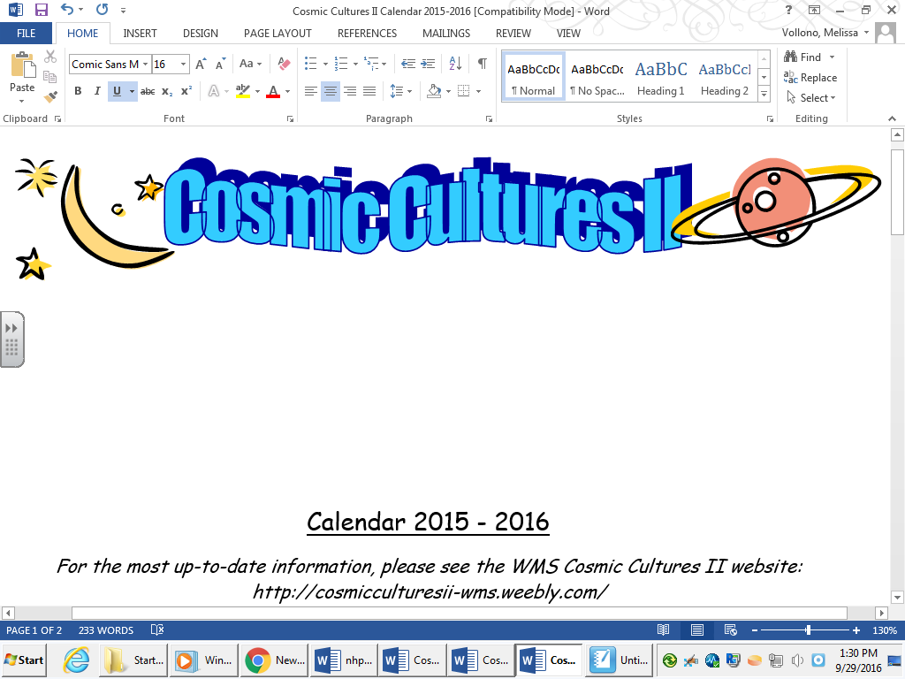

Calendar 2018 - 2019

*For the most up-to-date information, please see the WMS Cosmic Cultures II website: http://cosmicculturesii-wms.weebly.com/*

*\*\*\*Please be aware that* ***times/locations may change****.\*\*\**

*A permission slip will be sent out approximately 2 weeks before each event with exact details.*

|  |  |  |  |
| --- | --- | --- | --- |
| **Date** | **Time** | **Location** | **Purpose** |
| Friday, Oct 19th | After school to evening | West Side Middle School, Waterbury | Introduction to the program, intro to the night sky, team-building activities with Camp Sloper staff. |
| Friday, Nov 9th  Alt date: Nov 16th – weather dependent | After school to evening | Location TBD | Star Gazing Party with the Greater Hartford Astronomical Society |
| Saturday, Jan 26th | Morning to early afternoon | Mead School, Ansonia | Ancient World Cultures Day |
| Friday, Feb 22nd | During School | Peabody Museum, New Haven and the Eli Whitney Museum, Hamden | Explore ancient Egyptian civilization and create an Egyptian funeral barge |
| Saturday, April 6th | Morning to early afternoon | Tyrrell Middle School, Wolcott | Astronomy Day |
| Saturday, May 18th | Morning to mid- afternoon | Bushy Hill Nature Center, Deep River | Explore Native American culture and high ropes course challenges |

**C:\Documents and Settings\melissa.vollono\Local Settings\Temporary Internet Files\Content.IE5\SKZ3NXBM\MC900241087[1].wmfAfter school ends in June** – Tentative Cosmic Cultures Summer Camp. Students participating in the school year Cosmic Cultures program are welcome, although NOT required, to participate in camp.